**Preparing to sell**

1. To set up an account, parents must go to: <https://www.trails-end.com/>
2. Click on “Register”

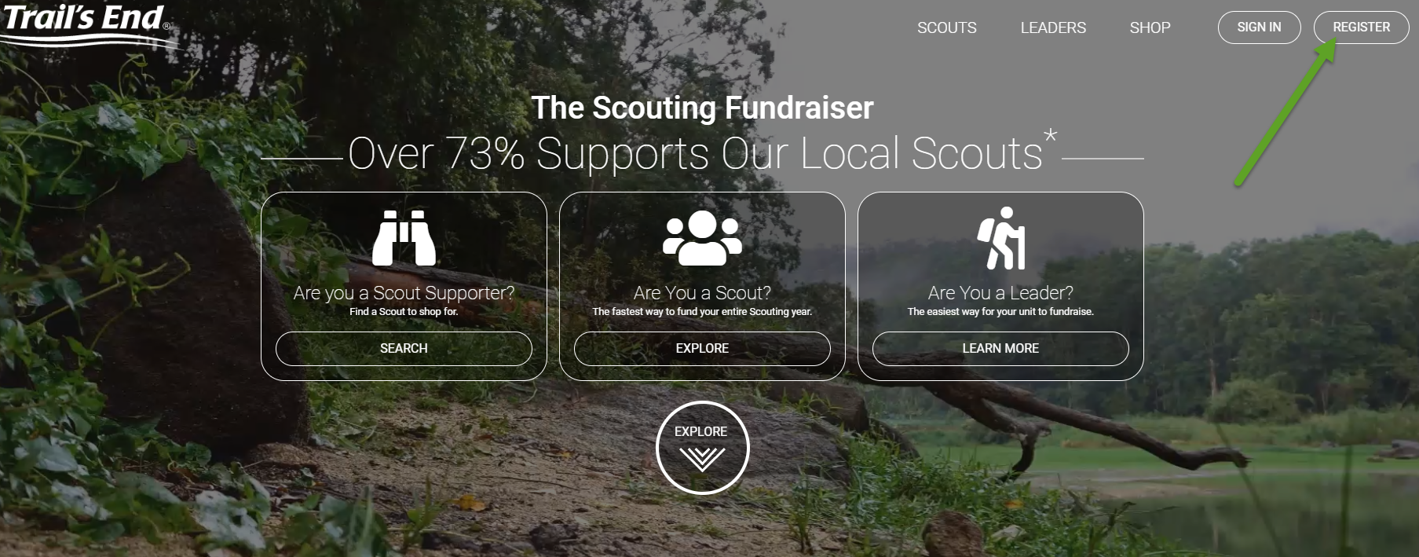

1. Enter information
2. Enter troop information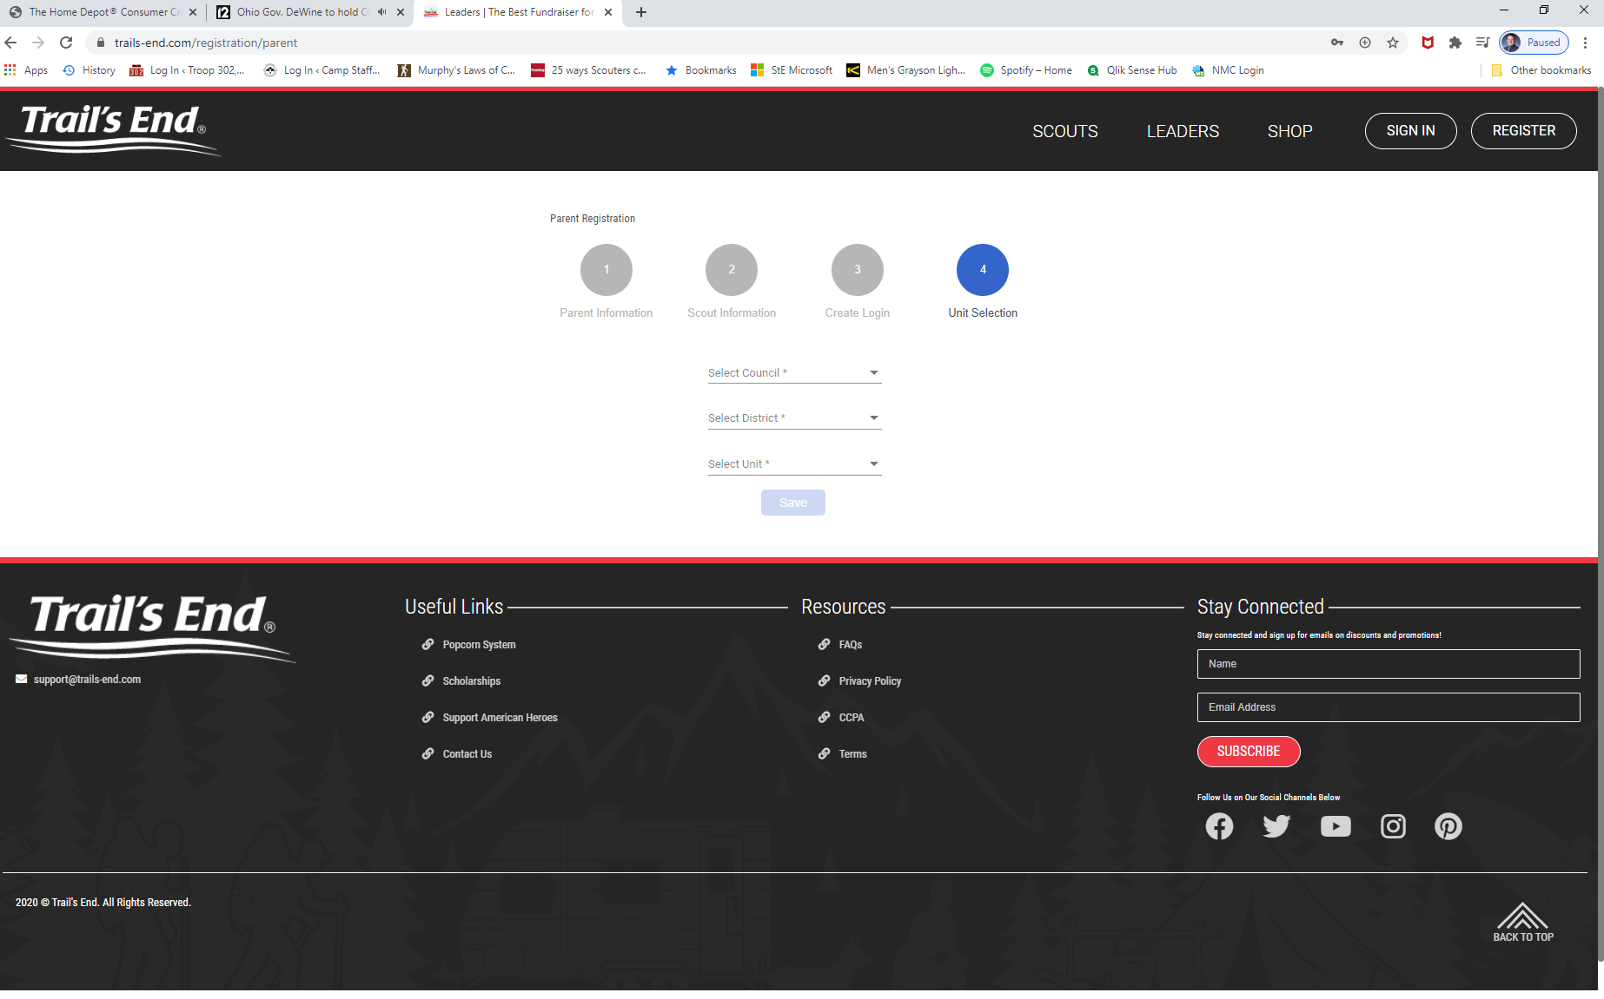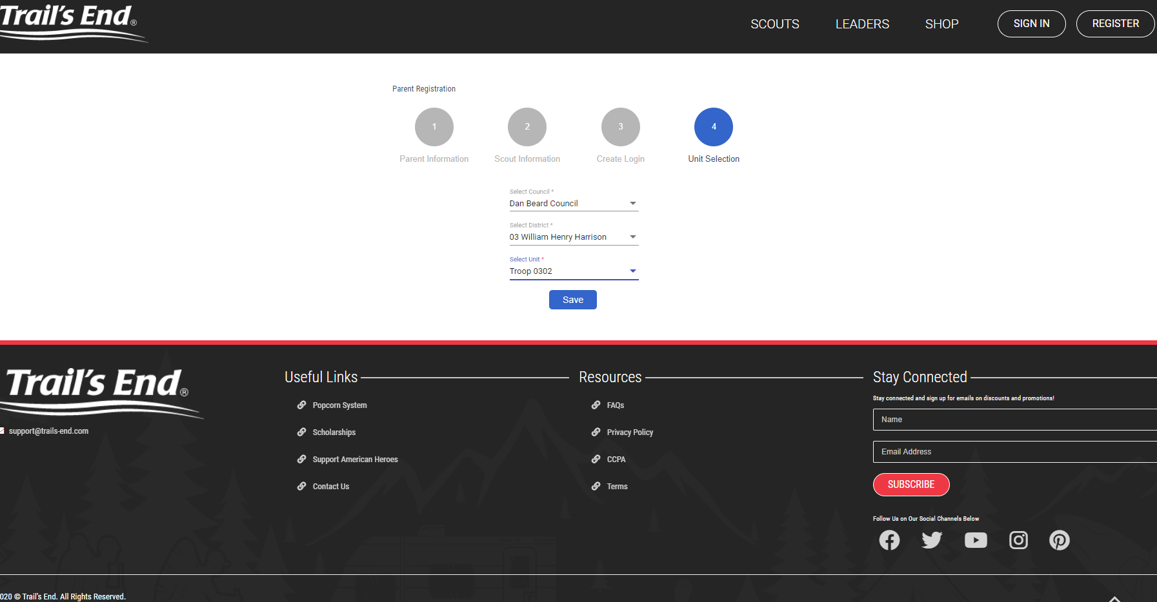
3. You now have access to the dashboard; look for your Scout’s “Scout code”

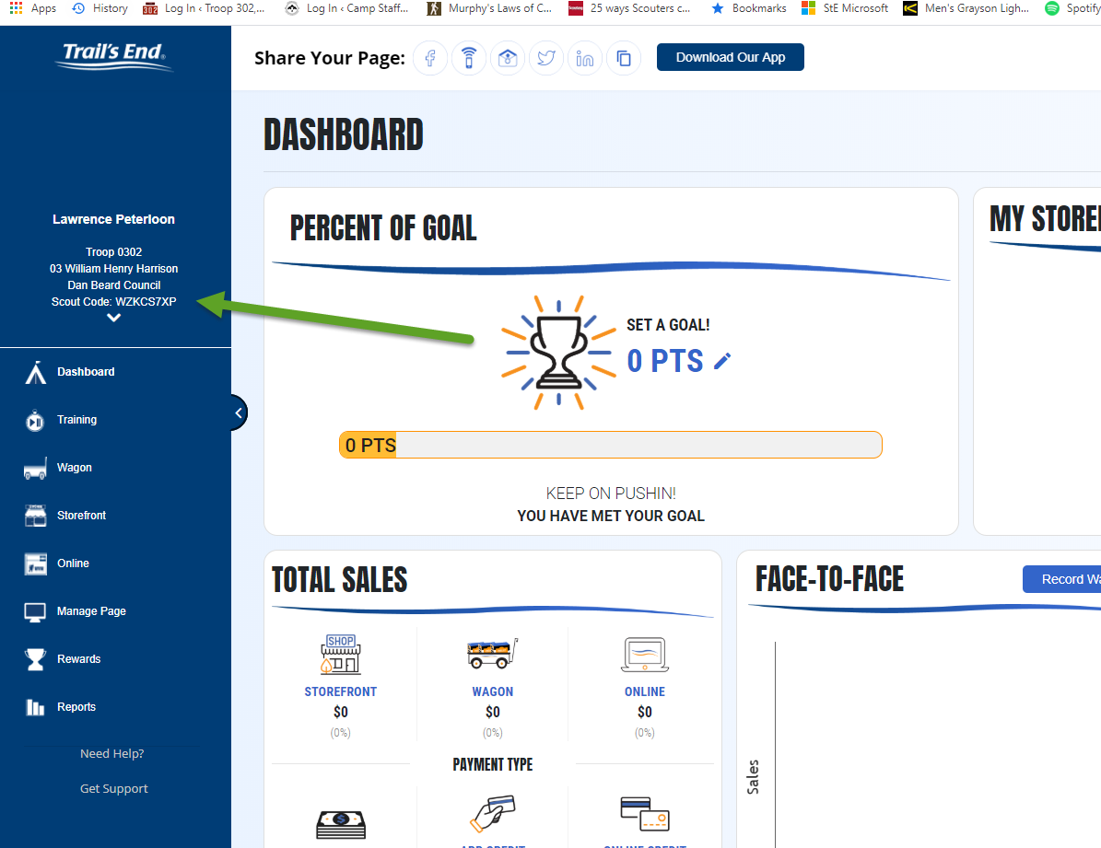

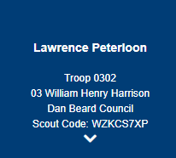

You can use the scout code to sell popcorn online, raising money for the troop!

**Sell Popcorn**

Popcorn sales raise money for the scout troop. 32% of revenue helps the scout troop to support scouts with financial needs, keep costs of camping trips low, provide fun events, purchase new equipment, and helps with the cost of summer camp.

Selling popcorn online makes sales easy because popcorn will go directly to the supporter, and transactions are handled online.

Please help the troop by selling popcorn to friends and family.

**To shop**, have friends go to : <https://www.trails-end.com/store>

They can paste your scout code so that their online order credits our troop!

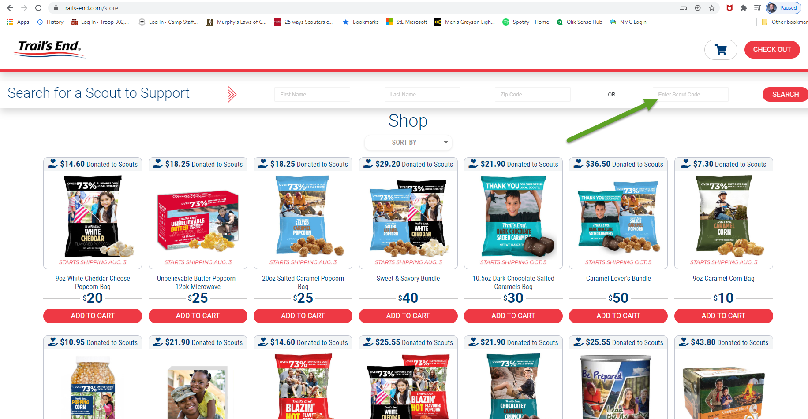

**Bonus:** Scouts will be awarded with amazon gift cards based on how much is sold under their name, which can be used to buy personal camping equipment!